Artist Market Application
June 23-25, 2023
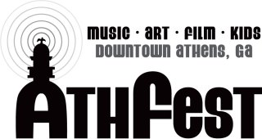

Thank you for your interest in participating in this year's AthFest Artist Market.

We expect to have 50-60 booths this year, depending on the quality and range of offerings. Creativity and craftsmanship are integral to the Artist Market. All work must be the original creation of the submitting artist. Therefore, commercial work suitable for a vendor booth will be referred to our vendor relations contact. Vendors pay significantly more for booths, do not go through judging, and are not eligible for awards.

Awards
Awards will be issued including: Best in Show ($200), Second Place ($150) and five honorable mentions ($50 each). This year, the honorable mentions will be awarded in the following categories:
- Best Booth
- Visual Arts (Painting, Drawing, Mixed Media, & Photography/Digital Art)
- Fabric, Clothing and Accessories
- Jewelry
- Hand-Crafted Items (Sculpture, Ceramics, Glass, Woodworking, & Furniture)

Required Examples for the Jury Process

It is imperative that you send images that clearly and accurately represent the quality of the work you intend to show at the market. You must send them by e-mail to: art@athfesteducates.org. Samples submitted this year will again be added to a Pinterest board to facilitate the jury process, and also to create some excitement among the general public about art to be featured at the festival. If you have presented your work at festivals before, please also send views of your booth. We hope to attract high quality work across all categories.

Deadline and Late Fees
- All submissions must be postmarked by April 1, 2023 and will be reviewed by a jury of respected local artists and members of the AthFest organization.
- E-mailed digital samples must also be sent by April 1, 2023 to art@athfesteducates.org
Each image should be submitted as a separate .jpg file attachment. Please do not send paper copies, CDs or actual artwork. Examples submitted in the wrong format will not be considered by the jury.
- Due to the extra effort required to review late submissions, there will be an additional $25 late registration fee for any submission received after April 1, 2023 and an additonal $50 late registration fee for any submission received after June 1, 2023.
- After the submission period closes, the jury will meet to select artists and selected artists will be notified on or around May 8, 2023. In the event spaces are still available after the initial selection, the artist market chair will submit exemplary submissions for continuing review by the jury, until all available spaces are filled.

Booths

- All booth spaces are 10 x 10. The artist must supply their own tents, tent/canopy weights, tables, lights and fans, extension cords, seating, and display materials.
- All both spaces must be weighted down with 35 lbs or more per pole.
- Electricity will be provided. We work with the county and a power supply company to provide portable sub-stations, but you must provide your own extension cord and any power strips required for your booth. Surge protectors are recommended. We recommend at least 50 feet of outdoor rated extension cords, though some locations may require a longer cord.
- Some security will be provided overnight. However, AthFest will not be liable for any damage, theft, injury or weather-related damage incurred during the festival. Your signature on the Artist Market Application signifies your acceptance of these parameters.
- Footprint and Flow of Foot Traffic. Due to fire lane requirements, we are required to maintain some open spaces for both foot traffic and emergency vehicle access. As such, you must keep your art and equipment in your booth space or immediately beside the booth, without impeding access. We will likely have two rows of single booths along sidewalks on both sides of the street, and a middle row of single booths in the middle of the street. Those backing up to sidewalks may use limited sidewalk space behind their booth for seating/storage. Those in the middle row can set up their booth as open on both sides or choose a direction to face if the booth incorporates a “back wall” or display.
- Location of Market: Upper Washington Street, between Hull and Lumpkin Streets. This section of Washington is a hill. Not a super-steep one, but definitely a hill. Please plan accordingly.

Fees
- Application Fee (per artist): $25 until April 1, 2023; $50 from April 2 – May 1, 2023; $75 after May 1, 2023. Please note that images must be received by April 1 to guarantee consideration by the festival jury.

- Booth Fees:
  - Middle Row (no back, open both sides): $200 per booth.
  - Sidewalk (can be set up with a back, and possible limited sidewalk storage/staging area): $225
  - $25 additional fee for near KidsFest area
  - $50 additional fee for end-of-row booth request (Spaces limited)
Booth-Sharing Fees:
  - Booths may be shared by up to 3 artists, but each artist must submit a separate application.
(i.e., selection is based on the individual artist)
  - There is a $35 booth-sharing fee per each additional artist.
- Late Registration Fee:
- After May 1, 2023, the registration fee goes up an additional $25/artist
- After June 1, 2023, the registration fee goes up an additional $50/artist
Sales Information
- AthFest does not charge a sales commission. Collection, reporting and payment of state sales tax is your responsibility.

Please see the next page for more specific information about how to submit your application and provide examples of your work for the jury's consideration. The open-air Artist Market is an integral part of AthFest. Booths feature fine arts and crafts for sale. Exhibited work may include ceramics, drawings and watercolor, paintings, folk art, furniture, photography, glasswork, handmade musical instruments, jewelry, mixed media, prints, woodwork, or sculpture. No commercial “kit” products, factory-made items, or found objects will be accepted. Please visit AthFest.Com for more information and pictures of last year's festival.

Submission Checklist

Each submission must include:

☐ A completed and signed artist market application form for each artist.

☐ Required Examples:
- No more than 5 images representative of the range and quality of your work
- 2-3 images of your booth at other festivals, if available.
- The preferred format is .jpg. Once you complete your application, send these ASAP via e-mail attachment to art@athfesteducates.org. Images must be received by April 1, 2023 to guarantee consideration by the festival jury.
- Please note that samples submitted may be used in publicity materials for the market, the festival website, and the festival social media.

☐ A Separate check for the entry fee for each individual artist ($25 per artist) made payable to: AthFest, Inc. This fee is non-refundable. An additional $25/artist for any application postmarked after April 1, 2020. An additional $50/artist for any application postmarked after May 1, 2020.
- ☐ A separate check for the booth rental fee (Middle Row: $200 or Sidewalk: $225 for 10 x 10 booth).
- If an artist is not selected, this check will be returned.
- If an artist is selected, the check will be deposited to the festival account in April.
- Artists submitting a combined check for the booth fee and the jury fee will be returned for failure to follow the application guidelines. Why? It’s just not cool to try and avoid paying an entry fee for a juried show, and it’s not fair to the other artists who face the jury process. Please follow the rules!
- Checks that are returned for insufficient funds may result in forfeiture of booth space at the festival.

☐ For shared booths, please submit a $35 check for each additional artist sharing your tent. (If 2 artists are sharing a tent, then include a second check for $35. If 3 artists are sharing a tent, then include 2 additional checks for $35).

There may be opportunities for double-sized booths, or additional space, but those will be offered depending on available space, and only after the initial artist selection has occurred. There will be an additional charge of $200 per 10 x 10 space, and it must be paid in full before the festival. Sending in extra payment at the time of application will not guarantee you a double booth, but will put you ahead of others expressing interest but not sending payment ahead of time. (i.e., if your check is in our hands, you get first dibs.)
In response to many requests for preferred placements, a limited number of preferred spots (ends of rows, areas near KidsFest, etc.) may be available. The number and availability of these spaces will be determined closer to the festival, and an additional fee will be charged for preferred placements. A few preferred spots are being held aside for the Festival’s official artist, last year’s best in show winner (if returning) and when applicable, art cars. These may be released closer to the date of the festival if not needed for these reasons.
Refunds

- The $25/artist application fee is non-refundable.
- If accepted to the Artist's Market, the signed application shall be considered a commitment to exhibit. Refunds will not be issued to artists once they have been accepted to the Market.
- In the event that the 2023 AthFest Music & Arts Festival permit is cancelled by Athens-Clarke County, you will receive a 100% refund of booth fees.

Steps

- Compile and Submit Your Application and Checks in One Envelope, and Send to:

AthFest
Attn: Artist Market
P.O. Box 327
Athens, GA 30603

Applications must be postmarked by April 1, 2023
- Send your Required Examples by e-mail attachment (.jpg format) to art@athfesteducates.org by April 1, 2023 to guarantee consideration.

Frequently Asked Questions

What are the Artist Market Hours?

- The Artist Market is central to the 3 days of the Festival. As such, artists are expected to display on Friday, June 23, Saturday, June 24, and Sunday, June 25.
- Friday: Load in and set-up from 12 pm to 4 pm, Market Hours: 5 pm-10 pm
- Saturday: Load in (for those that notified Artist Market Chair in advance) 8:00 am – 10:00 am, Market Hours: 12 pm-10 pm
- Sunday: Market Hours: 12:30 pm-8 pm. Break-down and Move Out: 8 pm-10 pm. Washington Street re-opens to traffic at approximately 10 pm.

How Long Do I Get to Unload?

- You will be e-mailed directions on how to enter and exit the festival area about a week before the festival. The load-in/out times will be listed on your pass.
- We ask that you unload your vehicle(s) as quickly as possible and then move them to parking. Your barricade pass allows you 15 minutes to unload. You should not expect to set up your entire booth before moving your car! Space is very tight, and it is important that we get vehicles out of the festival area as soon as possible. Once the festival is open to foot traffic, all vehicles must be out.
- If you are late to the festival (after 4 pm Friday, 10 am Saturday, or 11:00 am Sunday), you may not enter the festival area to unload. You may be allowed to park outside the foot traffic area and walk your items in.
Is Parking Provided?

- Yes. Parking is provided for artist vehicles, through an arrangement with Prestige Parking. Once you arrive and unload, you will see a Prestige Rep for information on where to park. Spaces for Oversized vehicles and campers/trailers are limited. Parking in the Downtown Parking Decks is free on Sunday.

Do I Have to Stay the Whole Time?

- It is our general expectation that artists exhibit during the advertised hours of the market. If you have a special circumstance, talk with the Artist Market Chair. Leaving early without giving notice may result in your exclusion from the Artist Market in the future.
Questions?
Submit any questions to the Artist Market Chair via e-mail to art@athfesteducates.org
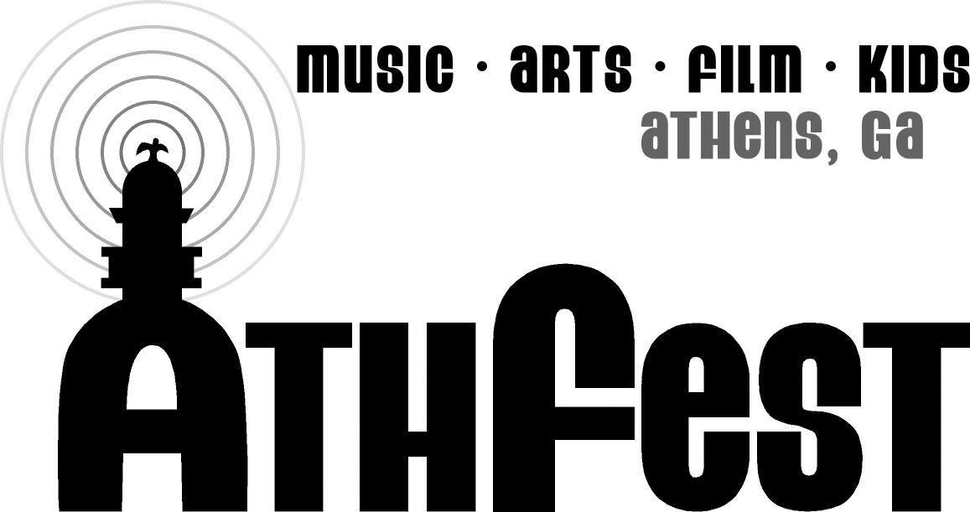
AthFest
Applications Must Be Postmarked
on or Before April 1, 2023
Submit any questions to the Artist Market Chair via e-mail to art@athfesteducates.org

Artist Name: |  |  | Sharing With Another Artist? (Name?)
Exhibiting As (If different from above):
Street Address (& Apt/Suite # if applicable) | City/State/Zip:
Phone Number: | E-Mail Address: |  |  | Website URL:
Name on Check (If not your name or your exhibitor name)
Category of Work (Circle One):
Visual Arts: Painting |  | Hand-Crafted: Ceramics
Visual Arts: Drawing |  | Hand-Crafted: Sculpture
Visual Arts: Photography and/or Digital Art |  | Hand-Crafted: Glass
Visual Arts (Mixed Media) |  | Hand-Crafted: Woodworking and/or Furniture
Jewelry |  | Fabric, Clothing & Accessories (Including soaps, custom toiletries, and items not in another category.)
The work you exhibit at the festival must be substantially similar to the examples you send with your submission. Failure to follow this rule may result in expulsion from the Artist Market, without refund. Additionally, all exhibited art must be made by you.
Additional Space &/or Preferred Placement Requests:  __ I am interested in being contacted if double-booth spaces become available. Attach separate check for additional fee of $200. Will be returned if not granted.  __I am interested in a preferred placement. Please contact me once preferred placement information becomes available. I understand that this will only be offered if circumstances allow. Please indicate type of preferred placement requested, and send a separate check. Will be returned if not granted.  __End of Row: Additional $50  __Additional Booth Space: $200  __ Near Kidsfest Additional $25  __ Other (Contact art@athfesteducates.org to discuss your needs. Additional fees will be set based on the availability of the space and complexity of your request.) |  | Payment Information Fee  *Application/Jury Fee $25  *Booth Fee (M: Middle/S: Sidewalk) $200(M) $225 (S)  *Booth Sharing Fee (Please indicate name of the main artist above so we can match with their assignment.) $35  (*Above items are required at initial application, and each must be on a separate check.)  Add-On Requests for Booth: Fee  †Additional Booth Space $200  † End of Row Request $75  † KidsFest Request $25  († You may submit payment ahead of time, or pay prior to festival.)  Total Fees Included with Application
Signature: |  |  | Date:

This is the only page necessary to return with your checks.

